BMW Case study

BMW creates some of the most high-tech cars we have yet seen. The German giant builds 2.5 million vehicles every year and sells them all over the world.
But technology is not just limited to the cars it builds, its business model is built on Big Data which drives everything it does across design, engineering, production, sales and customer support.
BMW is recognized for producing some of the most advanced vehicles on the market. The German automotive leader manufactures 2.5 million vehicles annually, distributing them globally.
However, BMW’s technological innovation extends beyond its cars; the company's entire business model is driven by Big Data, influencing every aspect of design, engineering, manufacturing, sales, and customer support.

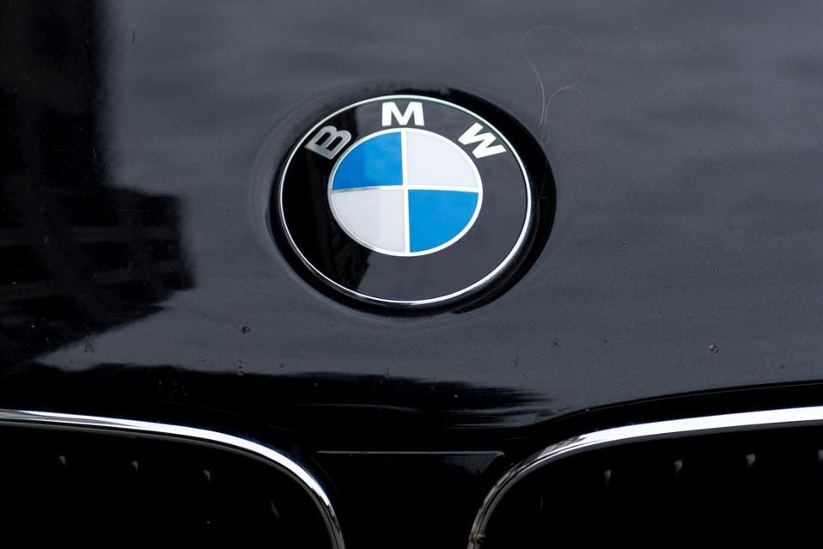

By leveraging Artificial Intelligence (AI), predictive analytics, and other cutting-edge technologies, BMW not only delivers the cars of today but also envisions and creates the vehicles of the future.
BMW is particularly confident in the shift toward autonomous driving. While all major automotive brands are investing in driverless technology, BMW stands out in its commitment to achieving full “Level 5” autonomy, with a target of reaching this milestone by 2021.
Level 5 autonomy represents the highest standard set by the U.S. Department of Transportation, allowing vehicles to operate without any human intervention, effectively performing as safely and efficiently as a human driver under all conditions and on all roads.
Key points to note where and how they used it.
- Autonomous Driving Development:
  - BMW aims to achieve full "level 5" autonomy by 2021.
  - They partnered with Intel and Mobileye for computer vision technology.
  - Data from cameras and sensors is analyzed in real-time for autonomous driving capabilities.
- Production and Quality Control:
  - BMW uses Smart Data Analytics to analyze data throughout the value chain.
  - They implemented a system to trace individual body parts throughout production.
  - Automated quality control uses AI and robots to scan entire vehicle surfaces, detecting errors invisible to the human eye.
- Predictive Maintenance:
  - Data analytics enables predictive maintenance across production lines.
  - This helps replace worn parts and highlight errors before they cause operational problems.
- Design and Testing:
  - AI is used to accelerate vehicle development and instantly predict performance in various situations.
  - Machine learning models are built from raw sensor data to understand system behavior and predict failures.
  - This allows for more efficient testing processes and scenario predictions without physical testing.
- Safety Analysis:
  - AI is used to analyze crash test data to improve vehicle safety.
  - Machine learning helps understand complex crash dynamics that are difficult to model with traditional simulations.
- Customer Experience:
  - BMW uses data to personalize customer experiences and develop connected mobility solutions.
- Manufacturing Efficiency:
  - Big Data is used to coordinate work, cut costs, and drive efficiencies across 31 assembly facilities in 15 countries.
  - Systems track parts from manufacture to vehicle sale, optimizing logistics.
- Partnerships and Innovation:
  - BMW partners with companies like IBM (using Watson for cognitive computing) and Here (for location data services).
  - They also work with AI startups through their BMW start-up garage initiative.
By integrating AI and Big Data across design, engineering, production, and customer support, BMW aims to improve efficiency, quality, and innovation in their automotive manufacturing and services.

